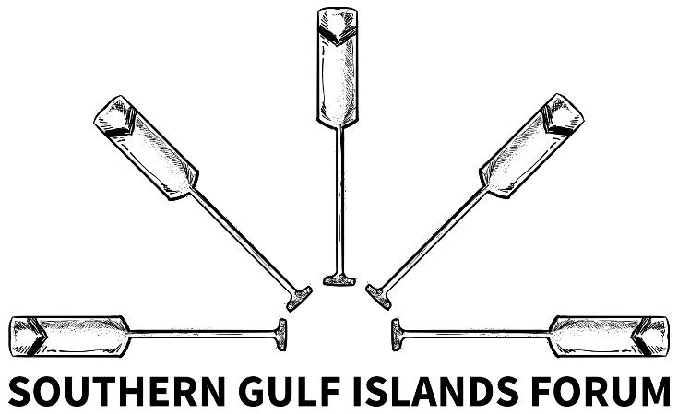

Meeting Minutes
Thursday March 5, 2026 – 9:00am-10:00am
Hybrid: MLA Botterell Community Office and Microsoft Teams

Attendees
Members (in-person and virtual):
- Chair: Earl Rook, SSI Local Community Commission Chair
- Tim Peterson, Island Trustee (Lasqueti Island), Vice-Chair of Islands Trust Council –
- Laura Patrick, Islands Trust Chair and Trustee (Salt Spring Island)
- Deb Morrison, Islands Trustee (North Pender Island)
- Chloe Straw, Program Coordinator, Islands Trust (Trust Area Services)
- David Maude, Islands Trustee (Mayne Island), Vice-Chair of Islands Trust Council
- Gary Holman, SSI Electoral Area Director, CRD
- Notetaker: Aysha Emmerson, Constituency Coordinator, Office of MP Elizabeth May
Meeting Opening (Chair, Earl Rook)

Chair offered a welcome/land acknowledgement. Participants introduced themselves. The previously approved agenda was outlined.

Updates from Representatives
1. LCC Updates from Chair Earl Rook
- The LCC is continuing to engage with community on a housing strategy, gathering trust for local improvements.
- SSI continues to struggle to secure public funding for housing and transit.
2. Islands Trust Updates from Trustees
- Trustee Laura Patrick
  - Trust Council meets next week in Duncan on Cowichan Tribes territory.
    - Chief Cindy Daniels will provide a welcome.
  - SSI Official Community Plan and Land Use Bylaw Update Project continues. The consultant currently working on this project will not renew their contract at the end of this year.
- Trustee Deb Morrison
  - Appointment to the IPCC has brought a whole new set of obligations for Deb, including missing Trust Council meetings.
- Trustee Tim Peterson
  - 89 acres on Galiano Island (two locations) will be returned to the Penelakut Tribe. Hopefully, by the end of Trust Council’s current term, the LTC will have adopted bylaws and subdivision will begin.
  - Trust Council budget meetings begin next week.
- Trustee Area Services Program Coordinator Chloe Straw
  - Public engagement on the Islands Trust draft policy statement was completed last month, and staff are now working with a consultant to analyze results.
  - Recently held the final session in this year’s Stewardship Education Program with a webinar on fallow deer in the southern gulf islands. The recording will be posted to the website in due course.
3. Federal Updates from MP Elizabeth May
- Elizabeth was too unwell to participate in person or virtually (nasty flu). She conveyed through Aysha deep regret at missing the meeting and looks forward to the next one.
- Aysha updated that, since January, MP May successfully wrapped up 9 community meetings and is currently engaged in a round of teen town halls across the constituency.
Discussion – W̱SÁNEĆ Leadership Council x SGI Forum

Summary: Pursuant of the January 9, 2026, meeting, Aysha outlined the SGI Forum engagement proposal developed by W̱SÁNEĆ Leadership Council staff, Eryn Rogers and Ned Taylor. Attendees agreed with the terms.

- Aysha → Given limited organizational capacity, Eryn and Ned proposed the following approach to their engagement with the SGI Forum:
  - They attend two SGI Forum meetings/year.
  - MP May's Office follows up with Ned/Eryn to place them on the agenda twice a year.
  - When WLC staff are placed on the agenda, members of the Forum are asked to come prepared with updates they feel are most relevant to WLC’s work.
  - Ahead of the meeting they attend, MP May's Office highlights items in the minutes or provides a high-level summary of discussions from meetings that have taken since we last attended.
    - This way, WLC can remain informed and come to the meeting with an understanding of what the Forum has done over recent months, without having to read the entirety of all the minutes that have been taken.
- Note: Eryn and Ned’s involvement in the Forum as staff does not constitute formal consultation with Tsartlip, Tseycum, or the W̱LC. Any correspondence coming out of the Forum should be mindful of this!

Action Item: MP May’s office will continue liaising with Eryn and Ned to determine which meetings they attend bi-annually.

Discussion – Virtual Spring Cross-Border Forum
Summary: Open discussion about the agenda and protocol for invitations to the upcoming spring cross-border forum.

- Aysha → Office of MP May continues to liaise with the Cross-Border Forum Working Group, regarding a virtual spring forum.
  - April 2 is held as the date for a virtual cross-border forum, but formal invitations have yet to be sent. An invitation list/draft letter is being finalized in the next few days and could be distributed as early as late next week.
  - Proposed goals/structure of the forum, as suggested by working group:
    - April forum focusing on relationship maintenance and practical collaboration across the border, especially given current political and economic uncertainty.
    - There is interest in: maintaining non-partisan dialogue; focusing on practical cooperation and shared challenges, and highlighting existing partnerships and opportunities for collaboration.
    - Proposed agenda is included as an addendum to these minutes.
  - An invitation list and draft letter are being finalized in the next few days, but no formal invitations have been sent beyond a “save the date” many months ago.
  - Question to the group: The April 2nd date is fast approaching, and formal invitations have not yet been sent. Will this give First Nations and Tribes enough time to participate?
- Trustee Peterson → Timing issues are not unusual in engaging with nations.
  - Suggests reaching out to the nations and asking if there is a date that would work better than April 2, 2026. What timing would allow the Nations/Tribes to send representatives? The rest of us can adjust.
  - As for a fall in-person meeting, a heads up that there will be local elections in October, with new Trustees sworn in in November. Consider a Jan/Feb in-person forum to maximize chances of success and hit the ground running with new relationships.
- Trustee Patrick → Appreciates the focus on oil spills, which dovetails nicely with the “political working group” on oil spills in our waters being established by Islands Trust. Will have more information about this working group tomorrow, after meeting with Justin from San Juan County.
- Trustee Morrison → Agrees with Trustee Peterson that we do not want to perpetuate a “neoliberal urgency problem.” Why is there urgency?
  - Not a fan of only giving short notice for Nations, even if it seems like enough time from a settler government perspective.
- All participants → Broadly agreed with the proposed spring forum agenda, and that the forum was non-urgent; it is best to ensure proper First Nations participation and protocol with invitations, rather than rush a meeting.

Action item: Aysha will discuss the possibility of moving the spring forum date with MP May and MLA Botterell, as well as with contributors to the Cross-Border Working Group.

Discussion – Enforced Removal of Derelict Vessels/Docks on SSI (Added to Agenda)

Summary: Arising agenda item—recent removal of derelict docks in Ganges by Transport Canada was welcome, but lack of notification prior was disconcerting.

- Director Holman → The clean up of derelict docks by Transport Canada recently in Ganges was very welcome, but it is disconcerting that there was no advance knowledge of this removal happening.
  - Local staff need to connect with the people in Transport Canada doing this work.
- Earl Rook → LCC has been stepping up to address derelict vessel/dock remediation, given the severity of the problem in Ganges.
  - Will send the CRD’s “what we heard” report
  - There was an initial meeting last spring about derelict vessels, and then more recently one that was Salt Spring focused and involved excellent representation from the Liveaboard community. There are plans underway for a second Salt Spring-focused meeting on the issue.
  - Staff from Transport Canada have been invited to the Salt Spring meeting.
- Trustee Maude → Can other southern gulf island trustees attend the SSI LCC meeting about derelict boats? These same issues are everywhere.

Action item: Earl Rook will speak with LCC staff about extending invitations to MP/MLA offices, as well as other Southern Gulf Island Trustees. The meeting is on April 16, 2026, on SSI.

Discussion – Next Steps on Issues Raised in Updates

- Aysha → Friday, May 22, 2026, is the next scheduled SGI Forum meeting; however, if we proceed with rescheduling the Cross-Border Forum for the same date/time, the Cross-Border Forum will take place in lieu. The SGI Forum will only take place virtually after the Cross Border Forum if urgent agenda items arise. Either way, hold the date.
- Action items summary:
  - Office of MP May (Aysha) will make a call out for the meeting Chair via email.
  - Office of MP May will speak with MP May and MLA Botterell, as well as the working group, about potentially shifting the April 2 Cross-Border Forum date to give more time for Nations to respond.
  - Earl Rook will extend invitations to MLA/MP staff and other Trustees regarding April 16 meeting about harbour management.

Addendum to Minutes

Draft Cross-Border Forum Structure (Proposed by Working Group - Feb 19, 2026)

- Opening / Welcome
  - Possible First Nations welcome (TBC)
- High-Level Political Updates
  - MP May / Rep. Larsen or other representatives
    - Brief reflections on cross-border cooperation priorities
- Context / Relationship “Stock-Taking”
  - How the cross-border relationship has evolved
  - What areas remain most important for collaboration
- Featured Speakers
  - Two speakers (TBC)
    - Potential: MLA Rick Glomack, Lt. Gov. Denny Heck, Nathalie Beaudoin, Dr. Laurie Trautman
  - Possible focus areas discussed:
    - Economic impacts across the border
    - Environmental collaboration
    - Transportation / ferry systems
- Audience Polling
  - Real-time polling during the forum
  - Questions may include:
    - How are current cross-border conditions affecting your work or community?
    - What opportunities do you see for collaboration?
    - What challenges are emerging?
- Breakout Discussions
  - Environmental Resilience
    - Oil spill preparedness (other than existing invitees, we should invite: Brendan Cowan + Canadian rep from emergency response ecosystem)
    - Emergency vessel coordination
  - Economic Resilience
    - Transportation and ferry reliability
    - Supporting cross-border business

